**JavaScript Exercises**

1. Write a javascript program to show date and time in this format: 2020-08-20 10:12:30

**Code:**

<!DOCTYPE html>

<html>

<head>

<title>Week 12 Task 1</title>

</head>

<body onload="DandT()">

<h2>Date and Time</h2>

<div id="txt"></div>

<script>

function DandT(){

const today = new Date();

let y = today.getFullYear();

let m = today.getMonth();

let d = today.getDate();

let hrs = today.getHours();

//hrs = hrs % 12; //to display in 12 hours format

let min = today.getMinutes();

let sec = today.getSeconds();

m = checkTime(m);

d = checkTime(d);

min = checkTime(min);

sec =checkTime(sec);

document.getElementById('txt').innerHTML = y+ "-" +m+ "-" +d+ " " +hrs+ ":" +min+ ":" +sec;

setTimeout(DandT, 1000);

}

function checkTime(i) {

if (i< 10) {i = "0" + i}; // add zero in front of numbers < 10

return i;

}

</script>

</body>

</html>

**Output:**

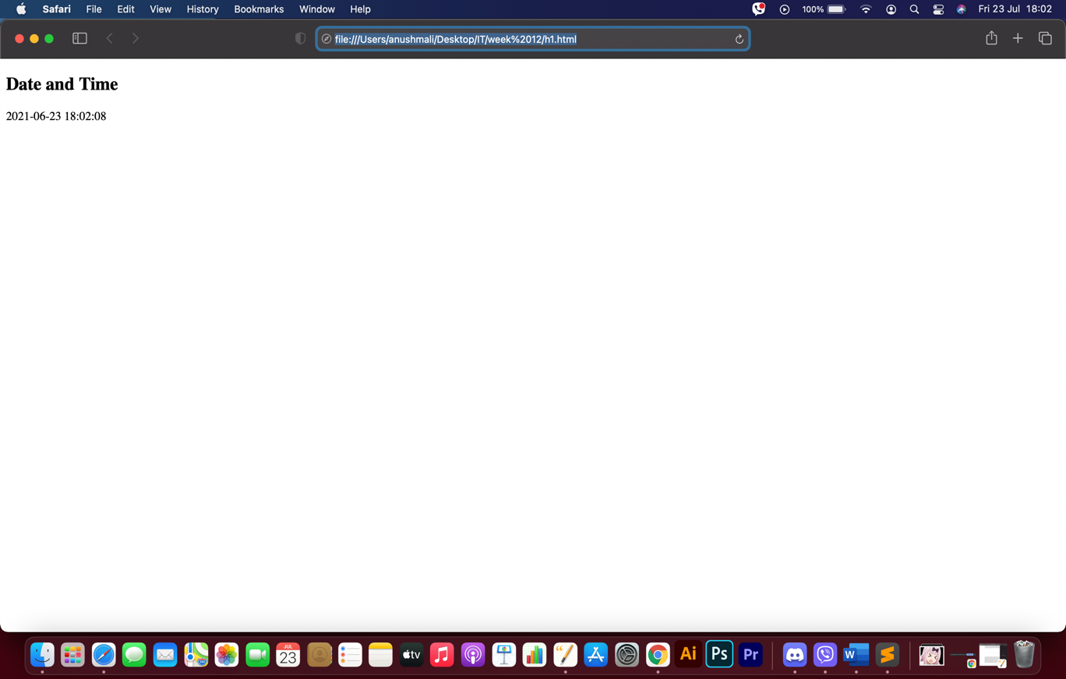

1. WAP in show javascript events for the following:
   1. Change the Text on <H1> when you click on that <H1> element. (Hint: use **innerHTML**property to set your text)
   2. When you click on the button, display date and time.

**Code for 2a:**

<!DOCTYPE html>

<html>

<head>

<meta charset="utf-8">

<title>Week 12 Task 2a</title>

</head>

<body>

<script type="text/javascript">

function ChangeText()

{

document.getElementById("text").innerHTML=("The text has been changed.");

}

</script>

<h1 id="text">Click button to change text</h1>

<input type = "button" onclick = "ChangeText()" value = "Click Me">

</body>

</html>

**Output for 2a:**

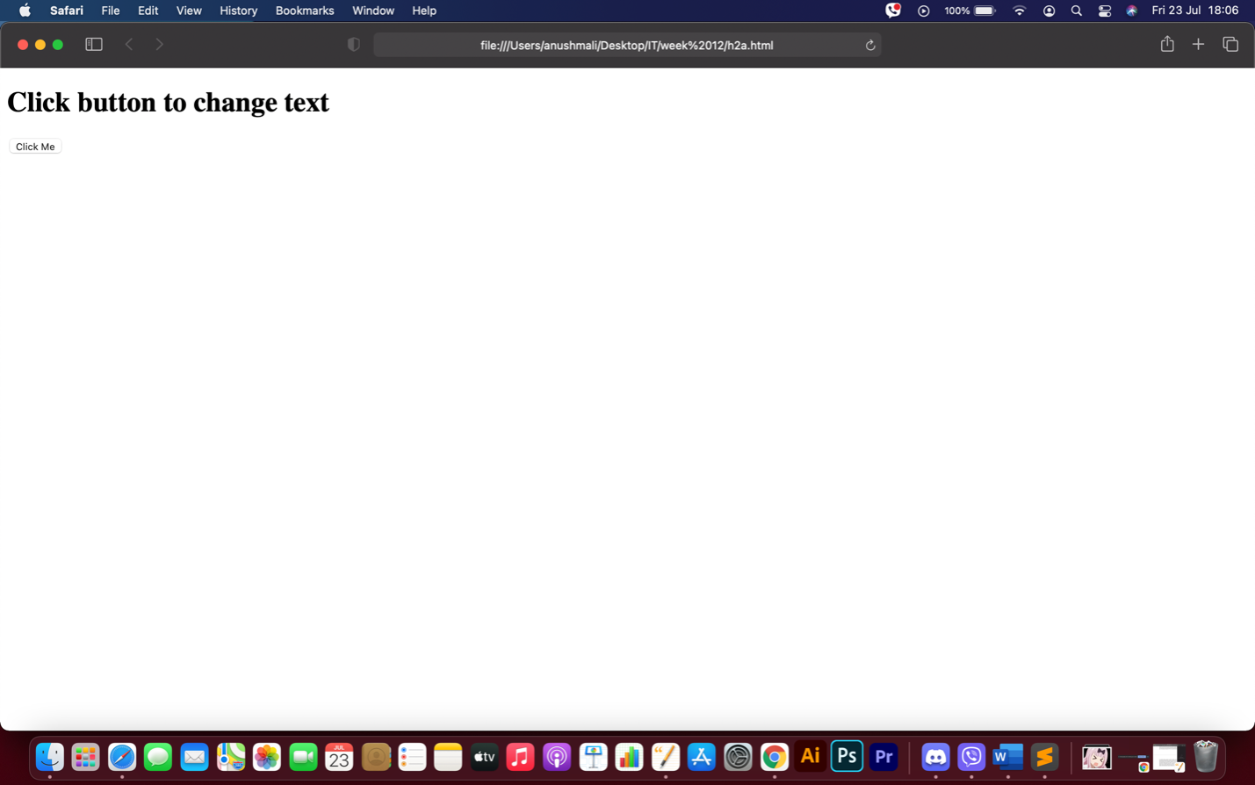

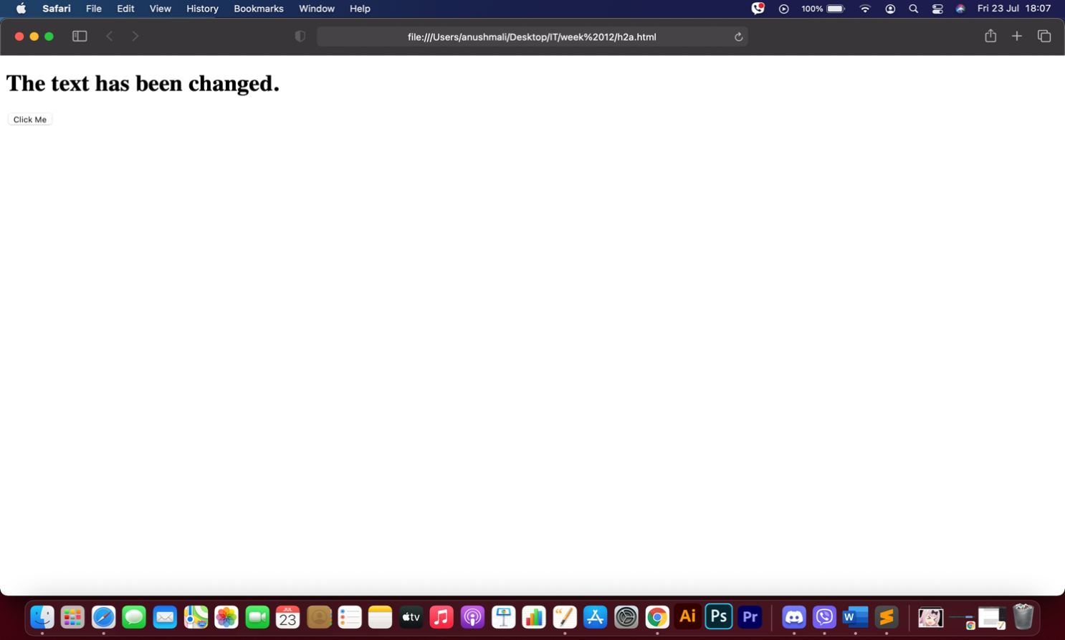

**Code for 2b:**

<!DOCTYPE html>

<html>

<head>

<meta charset="utf-8">

<title>Week 12 Task 2b</title>

</head>

<body>

<h1>Click button to show date:</h1>

<script type="text/javascript">

function currentDate()

{

var currDate = new Date();

var year = currDate.getFullYear();

var month = currDate.getMonth();

month++;

var day = currDate.getDate();

var hours = currDate.getHours();

hours=hours%12;

var minutes = currDate.getMinutes();

var seconds = currDate.getSeconds();

month = checkTime(month);

day = checkTime(day);

minutes = checkTime(minutes);

seconds =checkTime(seconds);

document.write(year + "-" +month+ "-" +day+ " " +hours + ":" +minutes + ":" +seconds);

//setTimeout(currentDate, 1000);

}

function checkTime(i) {

if (i< 10) {i = "0" + i};

return i;

}

</script>

<input type = "button" onclick = "currentDate()" value = "Click Me">

</body>

</html>

**Output for 2b:**

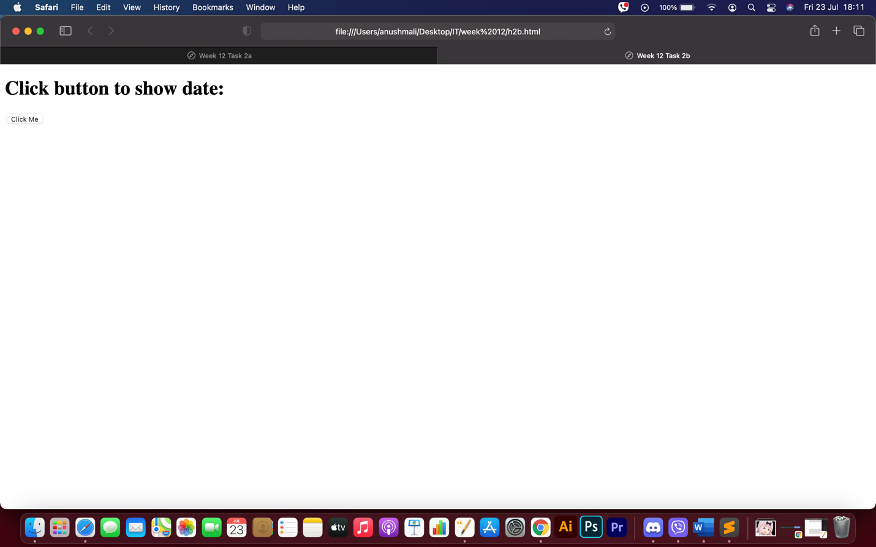

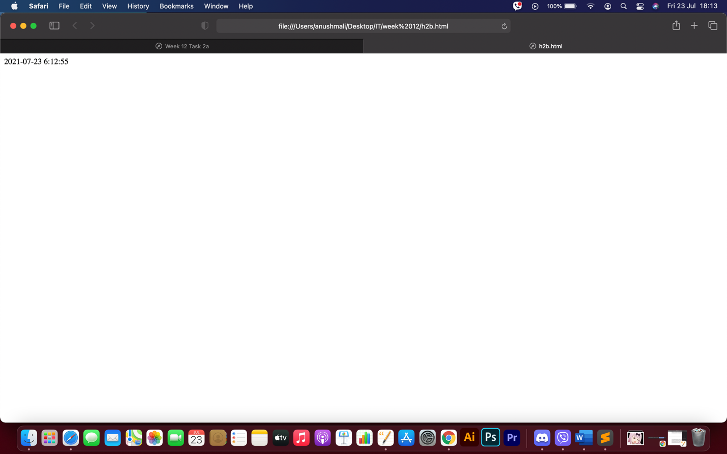

1. Write a Javascriptprogram to create function and call them in mouse events:
   1. Create mOver() function to show Thank You Text in the innerHTML of div element, and call this function on onmouseover event
   2. Create mOut() function to show Mouse Over Me Text in the innerHTML of div element, and call this function on onmouseout event.

**Code:**

<!DOCTYPE html>

<html>

<head>

<meta charset="utf-8">

<title>Week 12 Task 3</title>

</head>

<body>

<script type="text/javascript">

function mOver()

{

document.getElementById("demo").innerHTML = "Thank you";

}

function mOut()

{

document.getElementById("demo").innerHTML = "Mouse over me";

}

</script>

<div id="demo" onmouseover="mOver()" onmouseout="mOut()">Mouse over me</div>

</body>

</html>

**Output:**

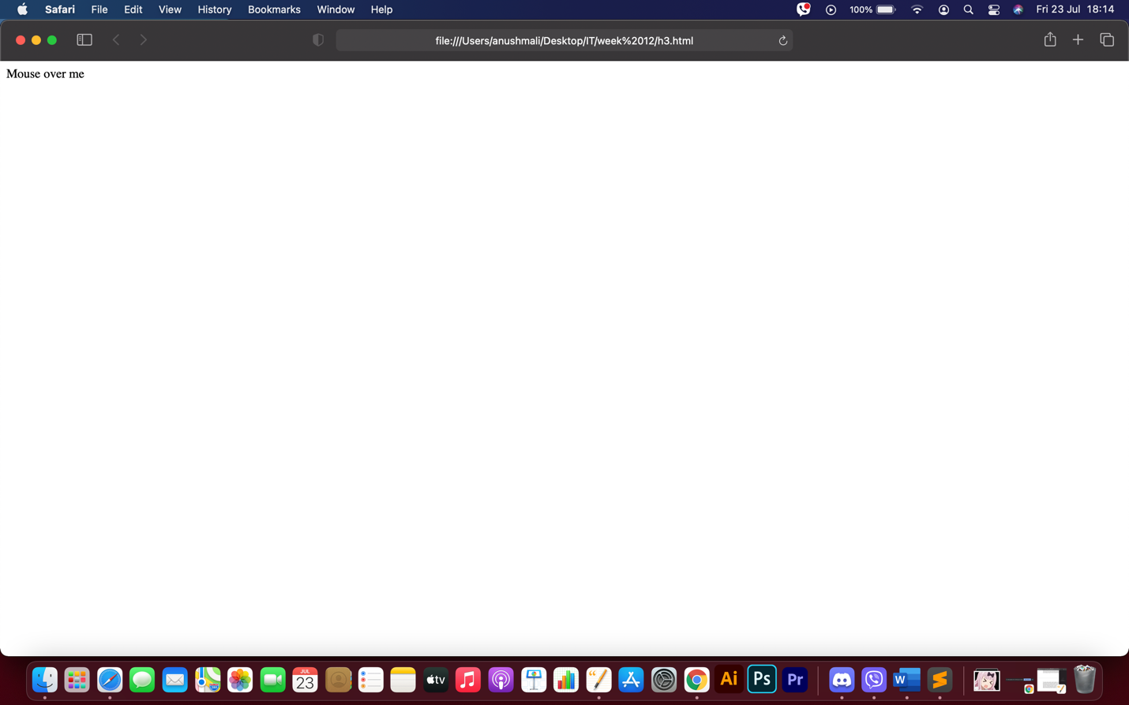

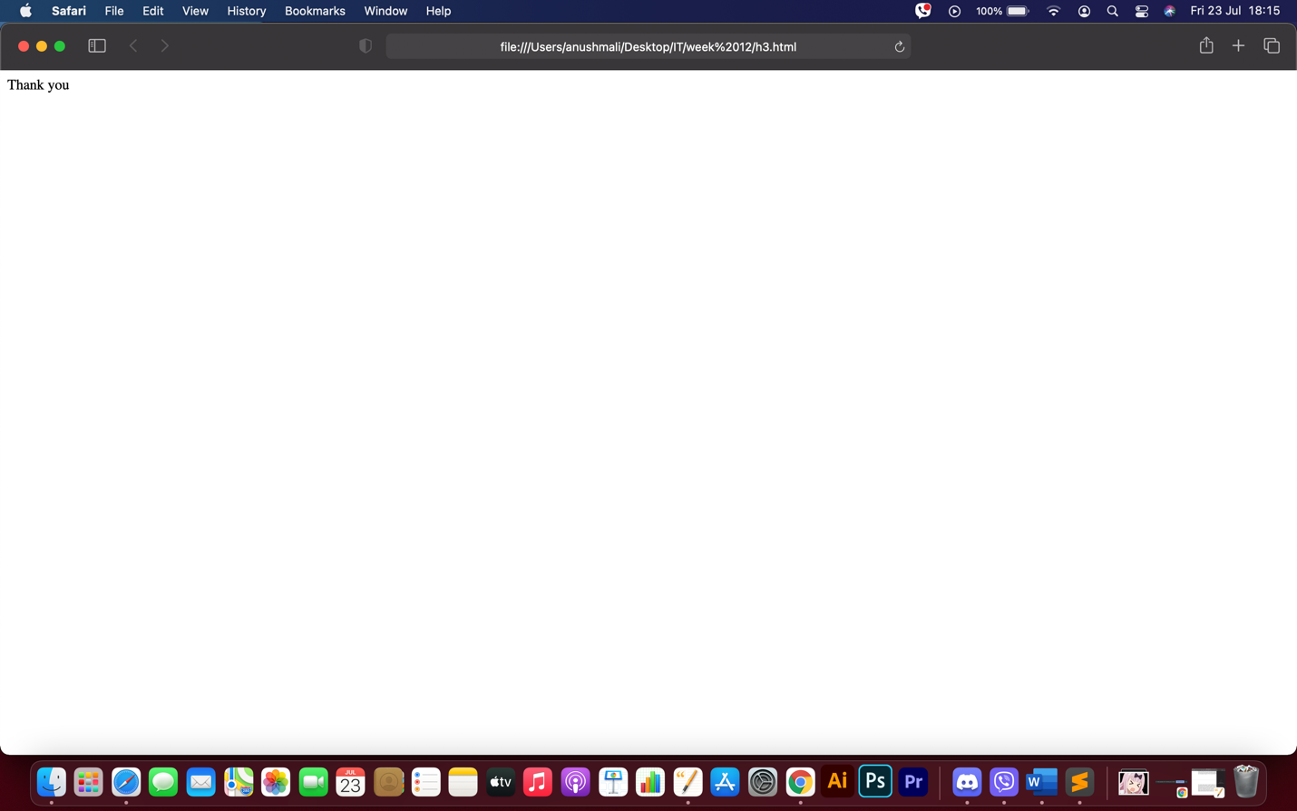

1. Write a JavaScript program to change the background color of a paragraph.

**Code:**

<!DOCTYPE html>

<html>

<head>

<meta charset="utf-8">

<title>Week 12 Task 4</title>

</head>

<script type="text/javascript">

function ChangeColor()

{

document.getElementById("color").style.background = "#ffb82b";

}

</script>

<body>

<p id="color">My name is Yoshikage Kira. I'm 33 years old. My house is in the northeast section of Morioh, where all the villas are, and I am not married. I work as an employee for the Kame Yu department stores, and I get home every day by 8 PM at the latest. I don't smoke, but I occasionally drink. I'm in bed by 11 PM, and make sure I get eight hours of sleep, no matter what. After having a glass of warm milk and doing about twenty minutes of stretches before going to bed, I usually have no problems sleeping until morning. Just like a baby, I wake up without any fatigue or stress in the morning. I was told there were no issues at my last check-up. I'm trying to explain that I'm a person who wishes to live a very quiet life. I take care not to trouble myself with any enemies, like winning and losing, that would cause me to lose sleep at night. That is how I deal with society, and I know that is what brings me happiness. Although, if I were to fight I wouldn't lose to anyone.</p>

<input type = "button" onclick = "ChangeColor()" value = "Click Me">

</body>

</html>

**Output:**

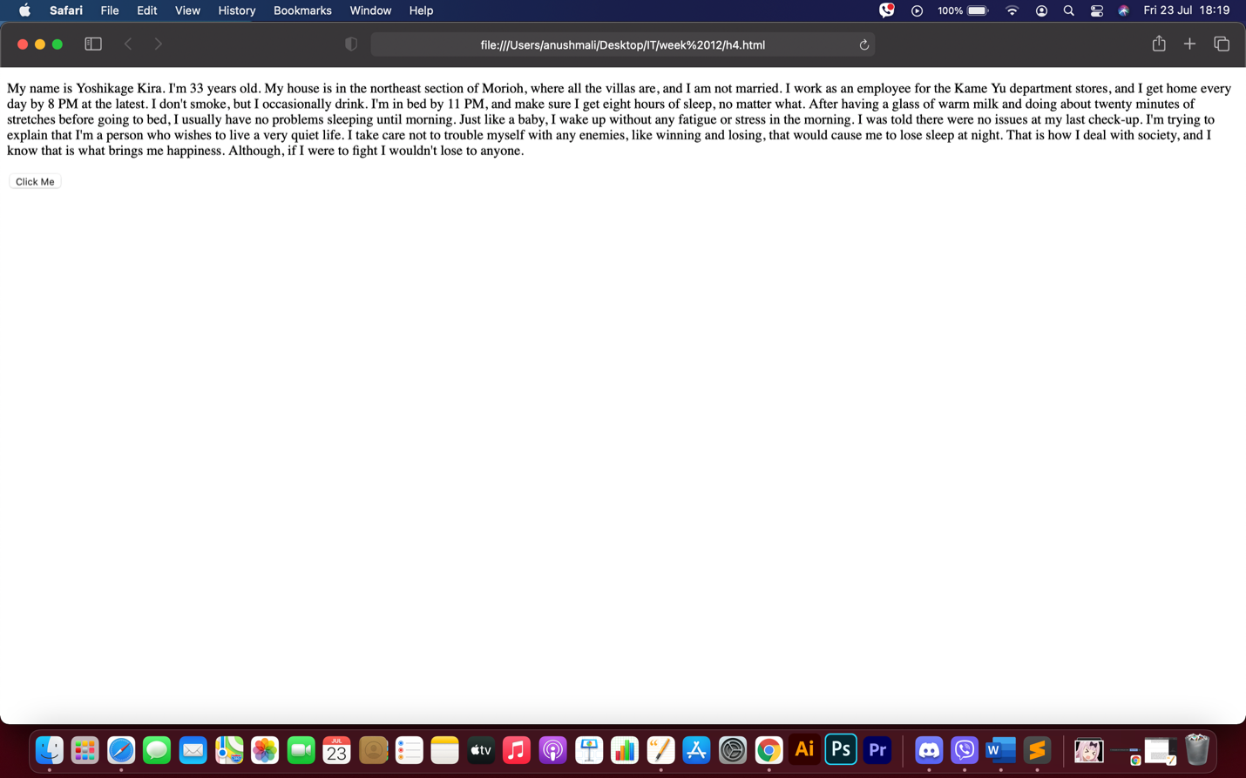

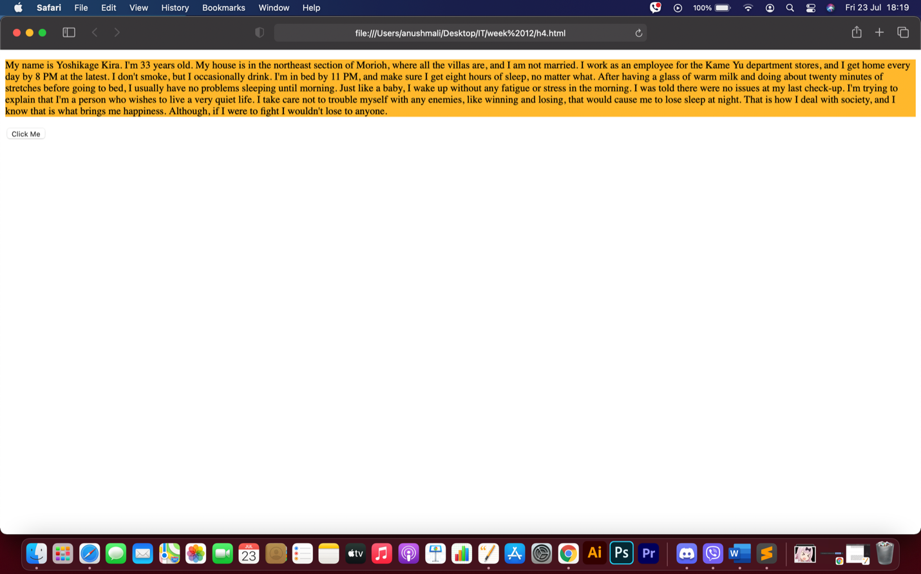

1. Write a JavaScript program to validate following.
   1. Check whether a given valuetype entered in text box is NaN or not.
   2. Check whether two inputs entered in password and confirm password text fields are same or not.

**Code for 5a:**

<!DOCTYPE html>

<html>

<head>

<meta charset="utf-8">

<title>Week 12 Task 5a</title>

</head>

<body>

<script type="text/javascript">

num=prompt("Enter a number");

if (isNaN(num))

{

document.write("It is NaN.");

}

else

{

document.write("It is a number.")

}

</script>

</body>

</html>

**Output for 5a:**

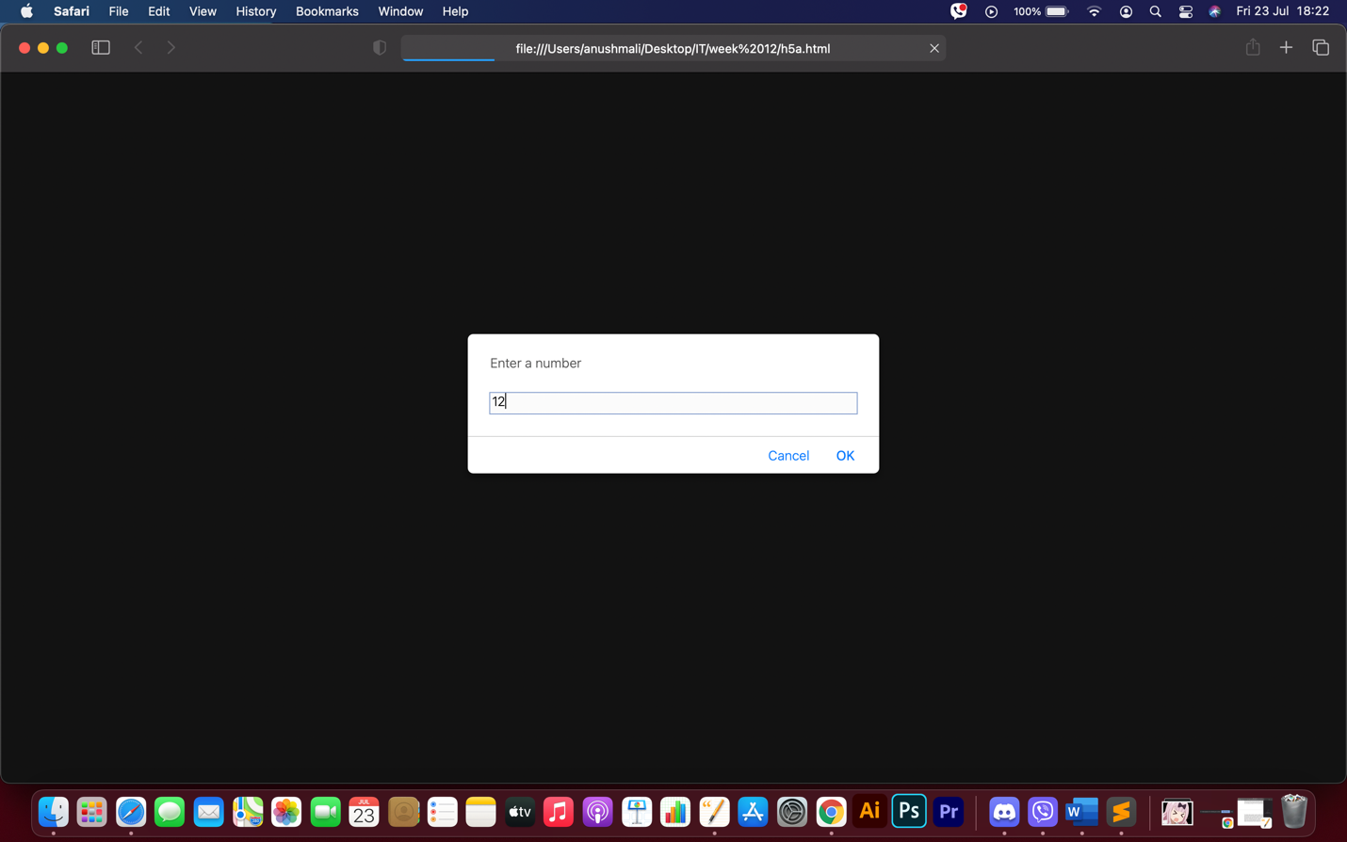

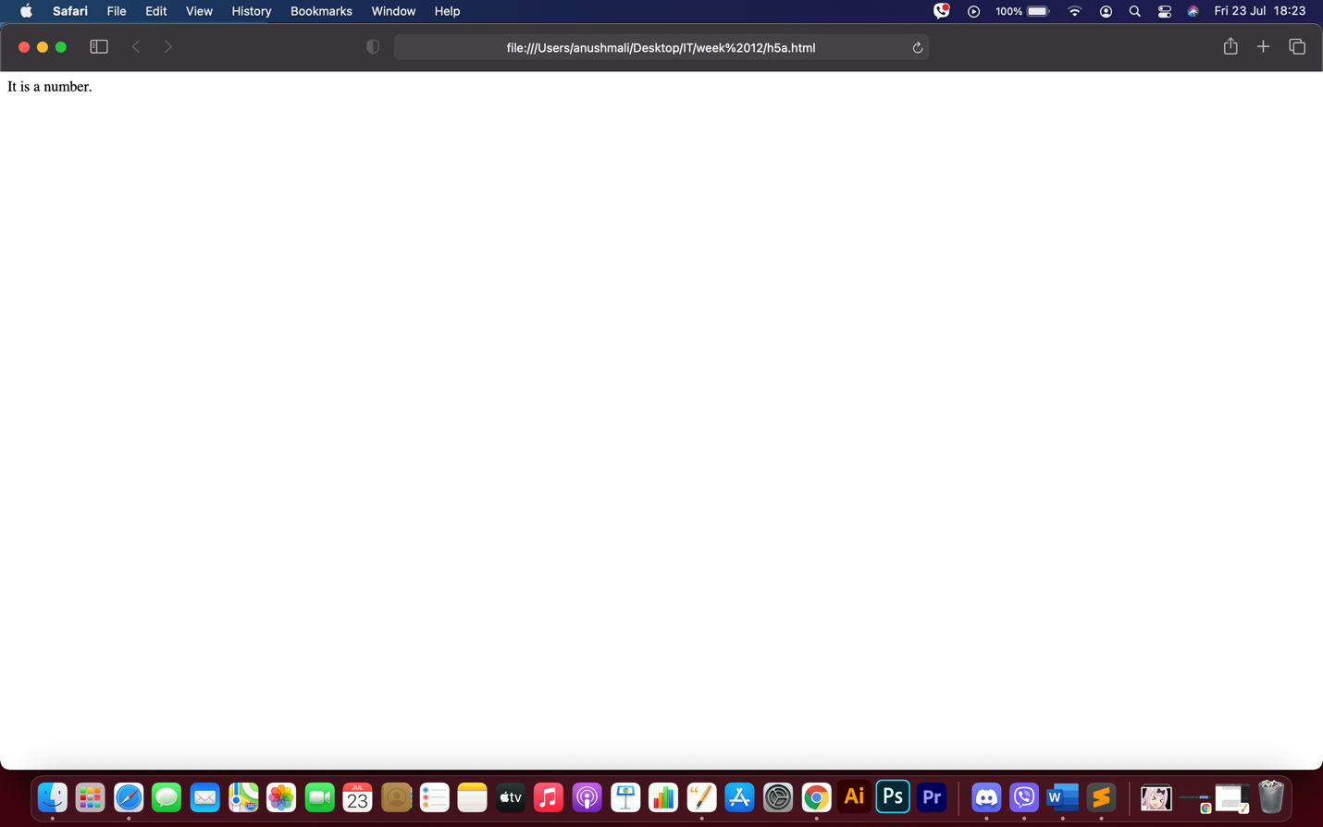

**Code for 5b:**

<!DOCTYPE html>

<html>

<head>

<meta charset="utf-8">

<title>Week 12 Task 5b</title>

</head>

<body>

Password:

<input type="password" id="Pass1" /><br><br>

Confirm Password:

<input type="password" id="Pass2" /><br><br>

<input type="button" id="btnSubmit" value="Submit" onclick="return Validate()" />

<script type="text/javascript">

function Validate()

{

var pass_1 = document.getElementById("Pass1").value;

var pass_2 = document.getElementById("Pass2").value;

if (pass_1 != pass_2)

{

alert("Passwords do not match.");

return false;

}

return true;

}

</script>

</body>

</html>

**Output for 5b:**

